NSW Department of Education

Using the 10wC activity tracker app guide
  - NSW Premier's Sporting Challenge
March 2026

Acknowledgement of Country
We recognise the Ongoing Custodians of the lands and waterways where we work and live. We pay respect to Elders past and present as ongoing teachers of knowledge, songlines and stories. We strive to ensure every Aboriginal and/or Torres Strait Islander learner in NSW achieves their potential through education.

Using the 10wC activity tracker app guide
Published by NSW Department of Education
First published: 2018
Updated: March 2026

Copyright and disclaimer
© State of New South Wales through NSW Department of Education, 2025. Information contained in this publication is based on knowledge and understanding at the time of writing, [Click here to enter Month Year], and is subject to change. For more information, please visit education.nsw.gov.au/rights-and-accountability/copyright
Contents
About the app 3
Accessing the 10wC activity tracker app 5
Mobile device – Android 5
Mobile device – iPhone 5
Desktop computer / laptops / tablets 6
Information for 10wC activity tracker users 6
1. Open the web app and log in with your Team code and PIN code. 7
2. Set your 10wC start date 7
3. Set your 10wC award level goal 7
4. Set optional 10wC Wellbeing Challenge goals 8
Home page navigation 8
10wC physical activity tracking 10
Adding activity 10
Challenge progress 11
10wC Wellbeing Challenge tracking 12
Launching the 10wC Wellbeing Challenge 13
Creating your wellbeing goals 13
Tracking wellbeing goals 15
Wellbeing goal progress 16

About the app
The NSW Premier’s Sporting Challenge (PSC) 10wC activity tracker app is available for use online by staff and students in Years 3-12 registered for the 10-week Challenge (10wC). The web app acts as an electronic logbook for participants in the 10wC activity tracking and synchronises data to the participant’s PSC Tracker e-Wall Charts. Additionally, the app can be used to track wellbeing goals for those taking part in the 10wC Wellbeing Challenge.
The app is available on any device - (https://www.10wctracker.com.au/).
Logging into the 10wC activity tracker web app online requires a team code and individual PIN code. PSC Facilitators can find these in 2 places on the PSC Tracker website (www.psctracker.com.au):
- on the Organisation admin page ‘10wC tracker app login details’ link, and
- on the School / Staff e-Wall charts pages ‘App login details’ link.
Staff/teachers can also view their team’s app logins and their (staff participant) login through the School / Staff e-Wall charts pages after logging in through the ‘10wC organisation login’ (see below). Ask the PSC Facilitator for the school/ office team’s username and password.
Users can ‘Download CSV’ of team and PIN codes from the ‘App login details’ page and save / share an excel sheet with participants for easy reference.
(Note: PSC Student Ambassadors can access School e-Wall charts and see the app login button but cannot access these links/app login codes.

Image 1: Screenshot of ‘10wC organisation login’ pathway on the PSC Tracker landing page.
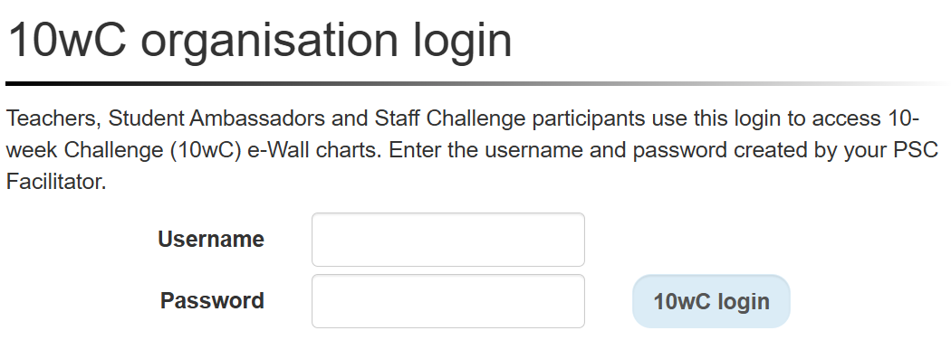

Image 2: Screenshot of the ‘School e-Wall charts’ with the ‘App login details’ button highlighted.
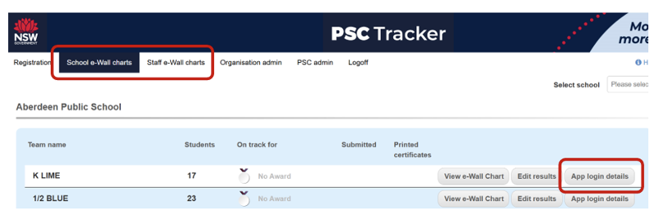

Accessing the 10wC activity tracker app
The 10wC activity tracker app (https://www.10wctracker.com.au/) is a web-based app and can be searched on any device (it’s not a downloadable app from the App store).
For easy reference, web-app sites can be downloaded on mobile devices and installed on desktop computers or added as a ‘Favourite’ page.

Mobile device – Android
- Search for the 10wC activity tracker app (preferable in a Google Chrome web browser).
- Find the ‘bookmark’ icon in the top, right corner and save to ‘Favourite’ pages.

Mobile device – iPhone
- Search for the 10wC activity tracker web app in a Google Chrome web browser: (https://www.10wctracker.com.au/).
- A pop-up will provide you with the option to ‘Add to Home screen’. If a pop-up doesn’t appear, tap the ‘share’ icon (bottom, centre) and follow the prompts.

Image 3: (Left) Screenshot of 10wC activity tracker app homepage with bookmark highlighted on an Android. (Right) Screenshot of 10wC activity tracker app homepage with bookmark and home screen install features highlighted on an iPhone.
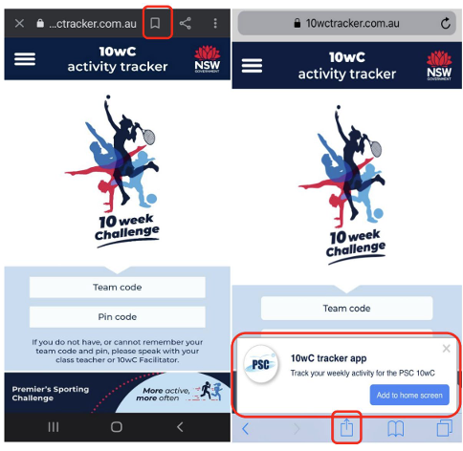

Desktop computer / laptops / tablets
- Search for the 10wC activity tracker web app (preferably in a Google Chrome web browser).
- Find the google “kebab” menu (3 vertical dots) in the top, right corner beside the URL address bar, click on ‘Apps’ and select ‘Install 10wC tracker’ or select ‘add to home screen’ in the pop-up message across the bottom of the screen.

Image 4: Screenshot of 10wC activity tracker app home screen with kebab menu and install on home screen feature displayed on a laptop device.
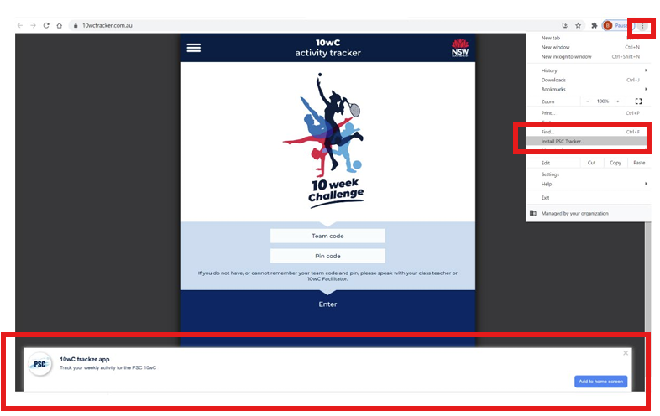
The 10wC tracker Icon will appear as a shortcut to the web app on the desktop and will keep the user logged in.

Information for 10wC activity tracker users

Open the web app and log in with your Team code and PIN code.
Image 5: Screenshot of the 10wC activity tracker app home screen showing the Team and PIN code fields highlighted.
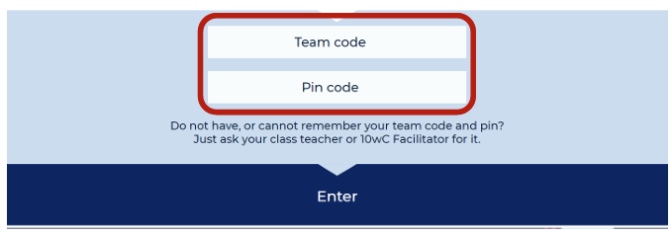

Set your 10wC start date
You will be prompted to enter your 10wC start date. Sometimes teams may not start in Week 1 of Term as they can complete the Challenge in any 10-week period. Some go through holiday period or start a week later in a 11-week term.
(Note: Challenge start dates are always Mondays).

Image 6: Screenshot of the ‘My challenge start date’ section in the 10wC activity tracker app.
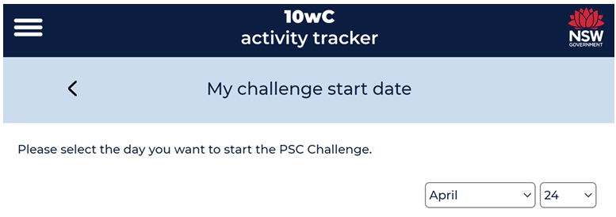

Set your 10wC award level goal
You will then be prompted to set a 10wC award level goal. Participants should aim to push themselves to work towards an achievable goal.
Note: You can edit your goal award level any time by clicking on the ‘Set my 10wC award goal’ link in the menu.

Image: 7: Screenshot of the ‘Set My Goal’ section in the 10wC activity tracker app for student participants.
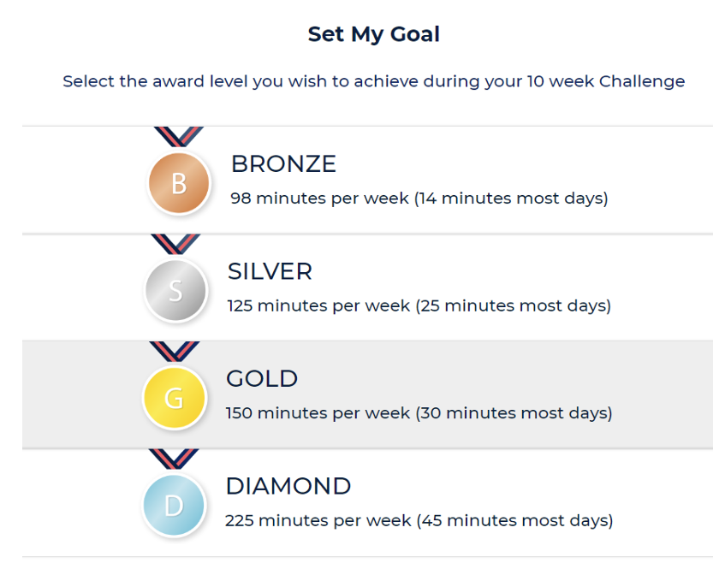

Set optional 10wC Wellbeing Challenge goals
Once the 10wC activity goal award is set, you will be sent to the ‘Add activity’ page where you can start to track your activity. However. If you wish to take part in the 10wC Wellbeing Challenge and set up to 4 wellbeing goals, please navigate to the home page to set these up - see page 12 for instructions.

Home page navigation
On the home screen you can:
- View the award level that you are on track for.
- View the ‘Challenge goal’ award level you wish to achieve and see how many more minutes of activity needed to achieve it for the current week.
- Click on the ‘Activity tracker’ to enter your daily or weekly physical activity.
- Click on ‘Challenge progress’ to see the weekly award levels you and your team (using the 10wC activity tracker app) have achieved.
- Click on the 'Wellbeing tracker' to create / track wellbeing goals.
- Click on 'Wellbeing goal progress' to see the how you're meeting your wellbeing goals for each week.
The hamburger menu in the top left provides quick navigation to above sections and additional information about the app.

Image 8: Screenshot of the 10wC activity tracker web homepage for ‘John Smith’ showing progress toward his goal of a Gold award where he is on track /currently achieving a silver award.
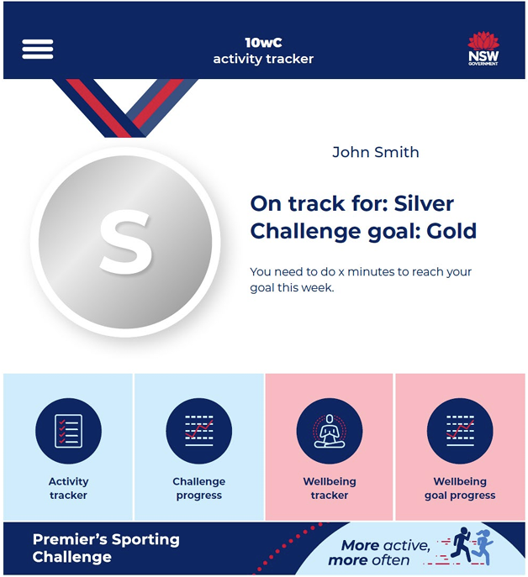

10wC physical activity tracking
The 10wC activity tracker web app allows participants to track their physical activity throughout the Challenge. As outlined previously, the app acts as an electronic logbook and synchronises to e-Wall charts in the PSC Tracker. This reduces the need for PSC Facilitator / classroom teacher / PSC Student Ambassador to add participant activity weekly awards throughout or at the end of the Challenge.
To begin, select the ‘Activity tracker’ section on the home screen to track your physical activity.

Image 9: Screenshot of the 10wC activity tracker app dashboard with the activity tracking challenge option highlighted.
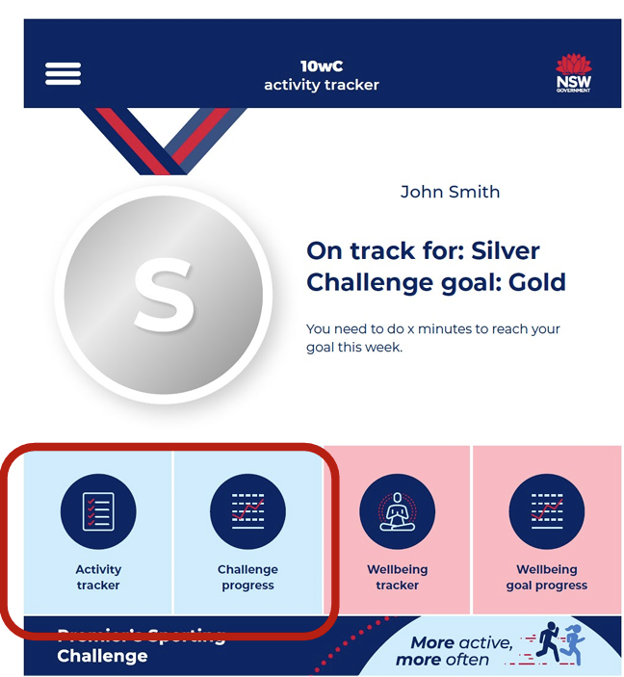

Adding activity
The ‘Activity tracker’ page will display as shown on the following page showing each week of the Challenge and the award level achieved for each week.
Clicking on a week will display the activity that has been entered for that week.

Image 10: Screenshot of the ‘Activity tracker’ section in the 10wC activity tracker app showing the weeks of the Challenge and options to ‘Add new activity’ highlighted.
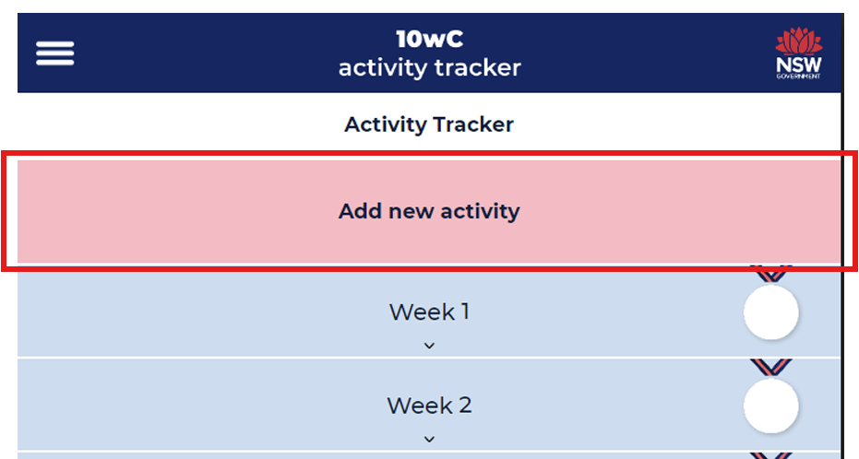
To track your activity, click ‘Add new activity’ and users are taken to a new page to add the activity:
- Select ‘Time’ or ‘Steps’ and enter your activity in minutes (preferred) or steps
- Type the activity (that you took part in).
- Enter the date – this will automatically update the ‘Challenge week’ (4.)
5. (OPTIONAL) If this is an activity that you do every week (consistently) you can check the box to add this activity to every week of the challenge to save time doing individual entries.
6. Click the ‘Add activity’ button.
You will then be taken back to the previous ‘Activity tracker’ page – see Image 10 above.
Note: Individual activity entries can be edited by clicking on the activity name in the weekly display.

Image 11: Screenshot of the ‘10wC activity tracker’ in the 10wC activity tracker app. Input fields are numbered corresponding to the steps above.
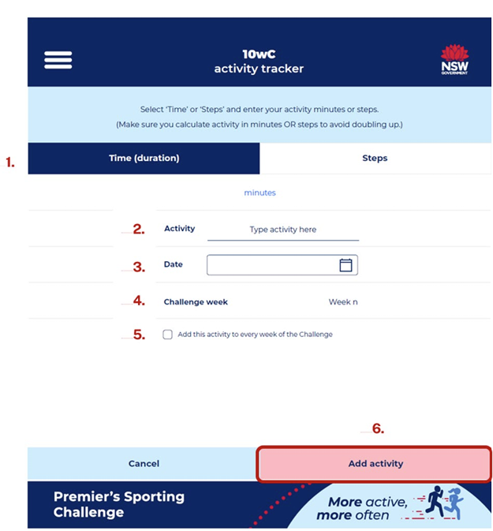

Challenge progress
Activity entered will be displayed in a graph in the ‘Challenge progress’ page.
Users will be able to view their tracked activity and compare it to their team average (of those using the app too).

Image 12: Screenshot of a bar chart in the ‘Challenge progress’ section showing challenge progress and comparison of the individual and the team in the 10wC Activity Tracker app.
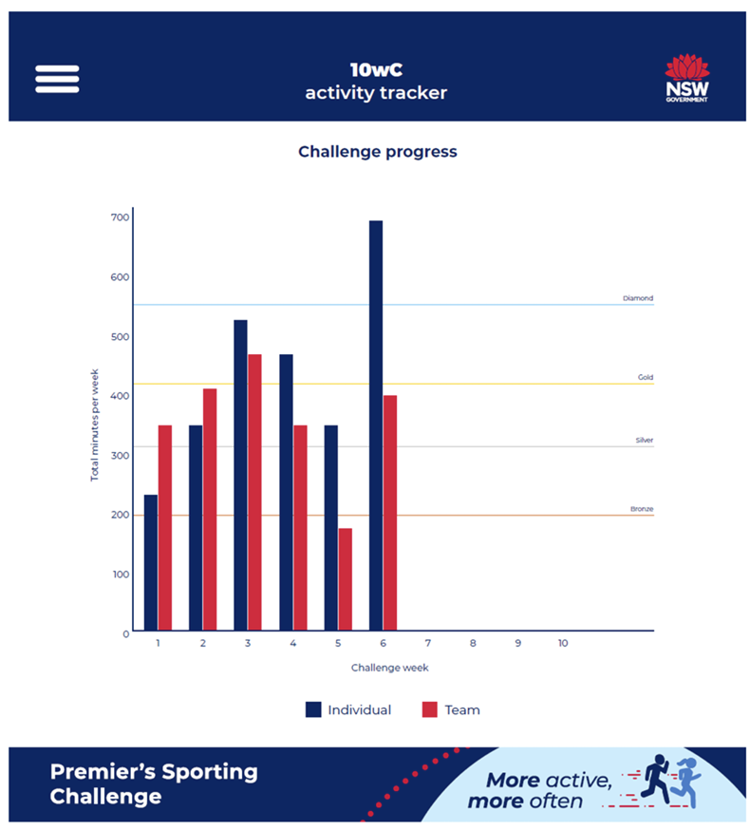

10wC Wellbeing Challenge tracking
Staff and students in Years 3-12 can take part in the 10-week Wellbeing Challenge where they can create and track up to 4 wellbeing and health goals over the 10-weeks of the Challenge.
K-2 students are not expected to take part in tracking of activity (minutes) or wellbeing goals. Therefore they cannot access this app. If they choose to take part will need to print a 10wC Wellbeing Challenge tracking table which can be found on the PSC activity worksheets webpage.
Note: Wellbeing goal tracking is OPTIONAL and will not affect your overall 10wC award level which is purely based on activity tracking. It is also personal and so other user can see your goals or achievements.

Launching the 10wC Wellbeing Challenge
The 10wC Wellbeing Challenge option is available on the app home page once a user has logged in.

Image 13: Screenshot of the 10wC activity tracker app home page for ‘John Smith’ with the 10wC Wellbeing Challenge options highlighted.
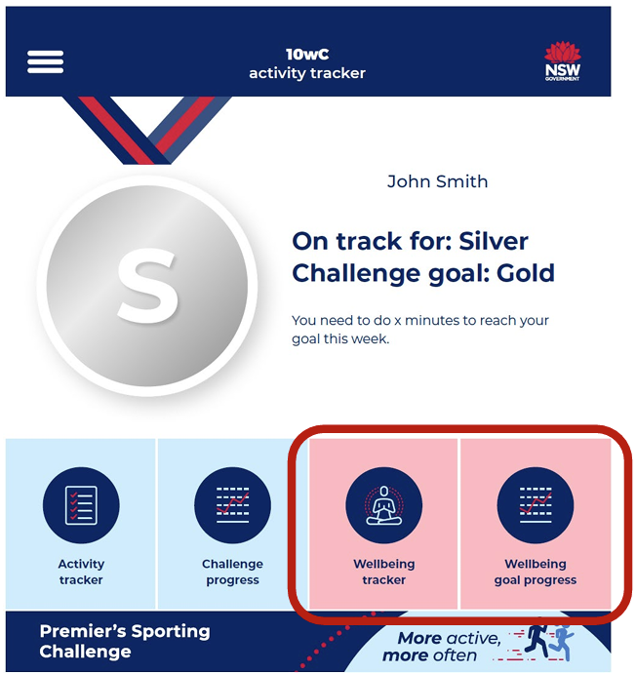

Note: Participants can also create / edit their wellbeing goals through the link in the (hamburger) menu at any time.

Creating your wellbeing goals
To enter wellbeing goals, participants select the ‘Wellbeing tracker’ on the home page (see image 13) and are taken to the ‘Set my wellbeing goals’ page to create up to 4 wellbeing goals to track over the 10-weeks of the Challenge.

Image 14: Screenshot of the ‘Set my wellbeing goals’ page in the 10wC activity tracker with ‘Create a wellbeing goal’ function highlighted.
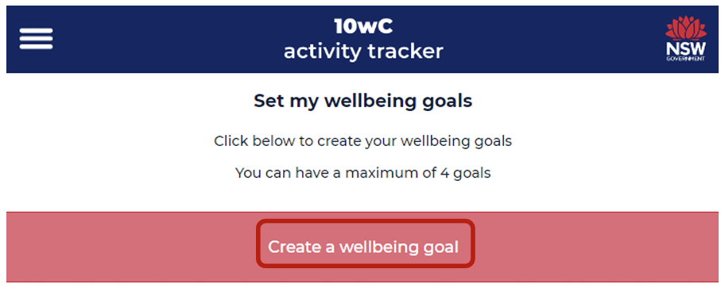
When a participant clicks on ‘Create a wellbeing goal’ section they are taken to a page to create individual goals. This process is repeated for each goal. The goals created are ‘daily’ goals (tracked daily) so should be written accordingly.
- Type the goal in the text box e.g. ‘<1 hour social media’, noting that each goal is a maximum of 25 characters in length.
- Select the icon that best represents the wellbeing goal.
- Select ‘Add goal’.
Image 15: Screenshot of the ‘Create a daily wellbeing goal’ page with ‘Some suggestion goals’ feature highlighted.
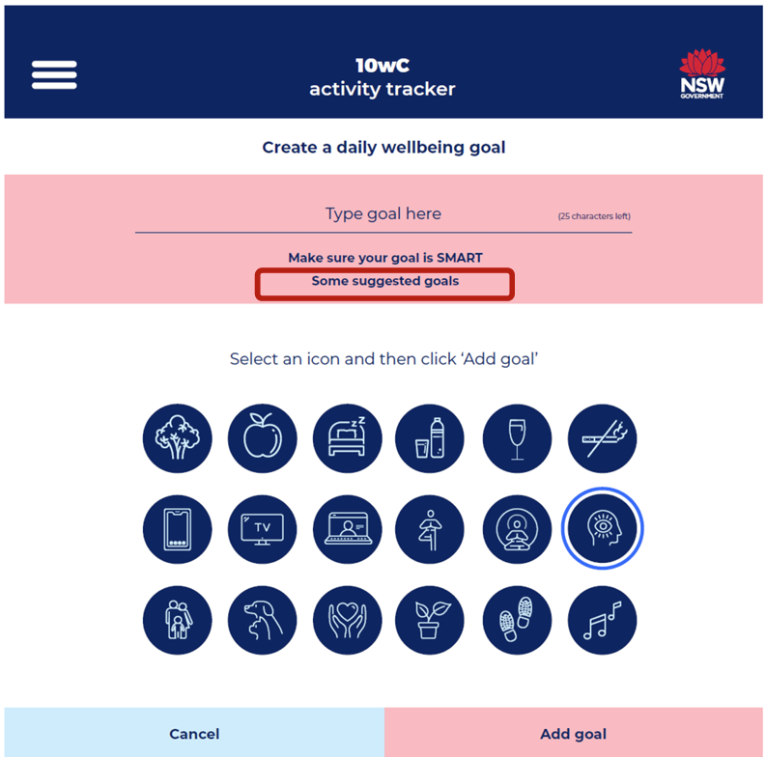
When a user clicks on the ‘Make sure your goal is SMART’ link they are shown the following information about the SMART goal setting method (see below) to create your goals.
Specific | What do you want to accomplish? How will you accomplish the goal?
Measurable | What criteria will you use to know you’ve achieved your goal?
Achievable | Is the goal realistic in your current and future situation?
Relevant | How is the goal related to improving your overall wellbeing?
Time-bound | When will this be achieved and what time-pressures exist?

When a user clicks the ‘Some suggested goals’ link on the page – highlighted in image 15, they are shown some examples of commonly created goals.

Tracking wellbeing goals
All wellbeing goals will be displayed in the ‘Wellbeing goal tracker’ section which is accessed through the home page or menu.
Once goals are created the ‘Wellbeing tracker’ page takes users to the ‘My wellbeing goals’ page where participants can track their goals (add stars) on the days of the week they have achieved each of the goals. Remember to click ‘Save’ after you have completed your data entries.
Note: You may navigate through the weeks to backdate any entries at any time. Complete all entries before saving. You are always taken to the current week that you are in.
Image 16: Screenshot of the ‘My wellbeing goals’ page with the ‘Edit my wellbeing goals’ highlighted.
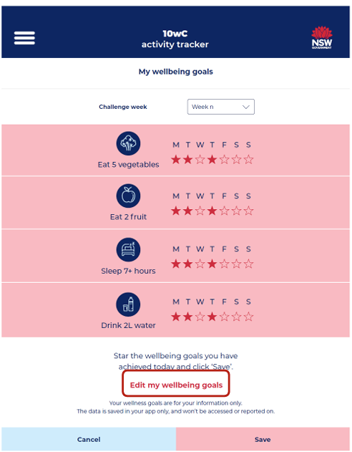
Users can edit / delete the wellbeing goals at any time throughout the challenge by clicking on the ‘Edit my wellbeing goals’ text. This will take participants back to the set/create wellbeing goals pages to edit accordingly where they then select ‘Save goal’.
Users can delete a goal if required (perhaps to create a new one, but please note that deleting a goal will clear all previously entered data for that goal.
Users are then taken back to the ‘Set my wellbeing goals; page where they click the ‘Close’ button at the bottom to return to the home page.

Wellbeing goal progress
Wellbeing goal tracking data will be displayed in a colourful bar graph to allow easy viewing of user’s goals achievement over the 10-weeks. Each goal is distinguished by a colour in the bar graph.
Note: These wellbeing goals cannot be viewed by any other user.

Image 17: Screenshot of a bar chart in the ‘My wellbeing goals – My weekly challenge progress’ page showing tracking days achieved for four goals over three weeks in the 10wC activity tracker app for this user.
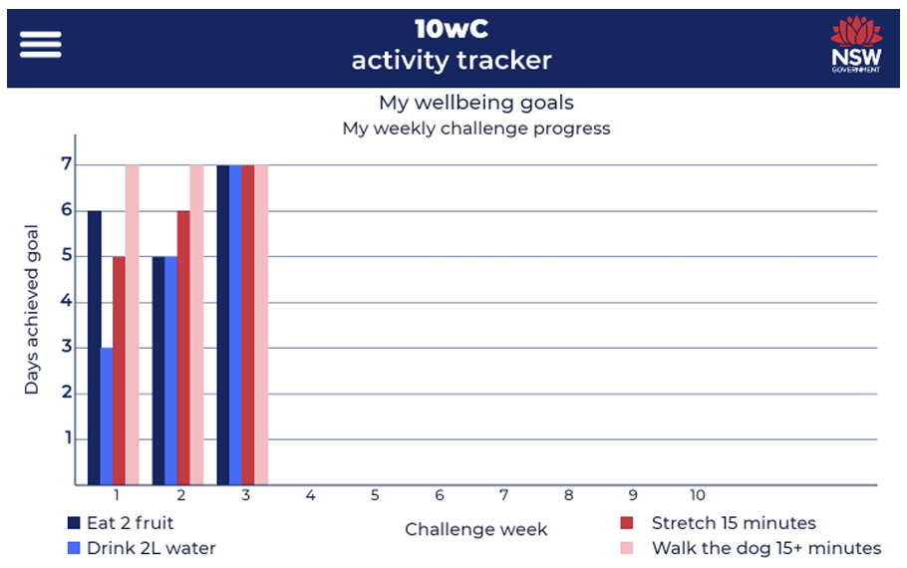
NSW Department of Education
NSW Premier’s Sporting Challenge
Level 2, 105 Phillip Street
Parramatta NSW 2150
0409845607
psc@det.nsw.edu.au app.education.nsw.gov.au/sport/premiers-sporting-challenge
© State of New South Wales through Department of Education 2025. You may copy, distribute and otherwise freely deal with this publication for any purpose, provided that you attribute the Department of Education as the owner.
The information contained in this publication is based on knowledge and understanding at the time of writing and may not be accurate, current or complete. The State of New South Wales (including the NSW Department of Education), the author and the publisher take no responsibility, and will accept no liability, for the accuracy, currency, reliability or correctness of any information included in the document (including material provided by third parties). Readers should make their own inquiries and rely on their own advice when making decisions related to material contained in this publication.
All images are owned by the NSW Department of Education under the Copyright Act 1968 (Cth) or licensed under the iStock Getty Images Content License Agreement.

