Sport and physical activity excursions – Risk management process and proforma

Risk management processes are used to identify hazards, assess risks and then eliminate or control risks associated with excursions.

The degree of planning is influenced by the nature of the excursion, the level of risk and the individual members of the student group. For excursions that have previously been planned and conducted, risk management plans may be reviewed, updated where required and reused.

An important component of the risk management process is consultation, which should include staff, and where appropriate external venue providers, parents and students.

Steps in developing the excursion risk management plan

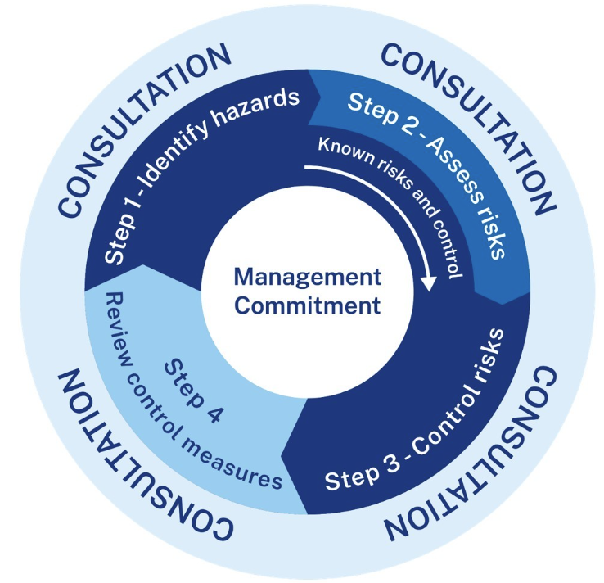
Identify the hazards
- List the activities of the excursion by-breaking the whole excursion into its parts, for example, getting to and from the venue, being at the venue, each of the major activities at the venue, meals (including their distribution), overnight accommodation, etc.
- Determine the hazards associated with the following: travel, the venue, activities at the venue, equipment used, the environment, people (for example, behaviour and medical conditions), accommodation etc.
Assess the level of risk
- Using the risk assessment matrix, determine the seriousness of the risks by considering both the likelihood and severity. This gives you a risk ranking from 1 being the least serious to 25 being the most serious.
Eliminate or control the risks
- Consider the most suitable control strategies for each of the identified hazards using the hierarchy of controls.
- Document the excursion risk management plan.
- Communicate the plan to excursion supervisors, staff and other adults on the excursion. Provide relevant information to participants and their families.

Monitor and review
- Monitor the effectiveness of controls and change if necessary. Monitor for new risks that arise during the excursion.
- Review the risk assessment if an incident or a significant change occurs.
An Excursion Risk Management Plan Proforma and Guidance in completing the Excursion Risk Management Plan Proforma provide assistance on hazard identification, the risk assessment matrix and the hierarchy of controls. This material may be used to develop and document the risk management plan. A Sample Excursion Risk Management Plan is also provided.
Principals should retain the documented plan as verification of the planning undertaken. The documentation will aid communication of the plan and can also be used in future excursion planning.
Checklist
Step 1 | Is a previous risk assessment for the excursion available? If so, review and update with reference to this checklist. Consider such issues as changes to the student group, current DoE requirements such as providing a general use adrenaline auto injector (i.e. EpiPen®) and an asthma inhaler and spacer in each first aid kit, individual student health care plans, the effectiveness of the controls and incidents on previous excursion.
Step 2 | Obtain venue information. Depending on the nature of the excursion and proposed activities, enquire about:  - public liability cover  - access and specific requirements, for example, students with learning and support needs  - accreditation of venue staff for the task/activity  - emergency procedures and relevant training of venue staff  - known hazards and controls related to proposed activities  - mobile phone and emergency services access for the excursion  - equipment available; confirm that equipment and machinery are maintained, repaired and in good working order with safety features operational  - use of licensed personnel for construction, maintenance and repairs  - availability of appropriate facilities, for example, showers, refreshments, toilets.  Plan strategies to support the health care needs of identified students prior to the excursion.  Where a student with a severe food allergy is attending an excursion minimise the risk of exposure to known allergens by  - determining procedures to cater for severe food allergies at the venue  - advise about the nature of the student’s anaphylactic condition, the foods that trigger anaphylaxis and the serious consequences for the student coming into contact with that food.  Parents/carers and, if practicable, the student should be consulted as part of this process.
Step 3 | Assess venue and safety information. Note this on the proforma and attach the venue and safety information to your risk management plan. If the venue is located in the vicinity of Sydney or major CBD, be aware of possible evacuation trials or plans (NSW State Emergency Management Committee: www.emergency.nsw.gov.au)
Step 4 | In consultation with key stakeholders, analyse the excursion and list the activities.
Step 5 | Identify the hazards associated with the activities and the potential risks associated with these hazards.  Important note about Step 5  - Where a student has a medical condition and are diagnosed at risk of an emergency, they are required to have an individual health care plan.  - Individual health care plans must be updated to address the student’s needs on the excursions. Excursions may pose different hazards to the school environment and the health care plan must be updated accordingly.
Step 6 | Assess the risks associated with the hazards using the risk assessment matrix. Consult with staff throughout the process.
Step 7 | Develop appropriate strategies to eliminate or control the risks (including action to ensure that child protection procedures are followed, health care plans are updated, and that all necessary aids and equipment are available) using the hierarchy of controls.  Where adjustments are being considered for a student with disability, consultation must take place with their parents/carers and the student, where practicable.
Step 8 | Document the risk management plan including emergency management procedures to deal with potential incidents. The attached proforma may be used. Refer to the Sample bushwalking Excursion Risk Management Plan for examples.
Step 9 | Communicate the plan to those who need to be informed in order to discharge legal obligations to students.  - excursion supervisors  - venue personnel  - participants and their families.  - Encourage students to advise staff if they or one of their fellow students is unwell, so that appropriate action can be taken.
Step 10 | Review the excursion risk management plan on completion.

Guidance in completing the risk management plan proforma

Hazard identification

The following may assist with identifying hazards relating to activities at each stage of an excursion. Consider what could go wrong, including the potential for injury or illness.
Travel – Consider aspects of travel such as walking to and from the train, crossing the road, transport to the venue. If CBD location, consider travel arrangements in the event of lockdown or evacuation.
Venue – Consider aspects of the venue that may present a hazard such as location near water, cliffs, crowds, slippery floors. If CBD location, consider possibility of CBD lockdown or evacuation due to evacuation trial or major emergency
Excursion program activities – Consider aspects of the activities that may present a hazard, such as bushwalking, collecting leaves, observing animals, swimming, climbing, eating at different venues.
Equipment – Consider any equipment that may present a hazard, for example, sporting equipment, high risk equipment at the venue.
Environment – Consider aspects of the environment that may present a hazard including weather conditions; natural hazards such as bushfires, floods or storms, the nature of the terrain, plants, animals and insects.
Consider common allergens that may pose a hazard, for example, foods, insect stings or bites, latex (balloons or swimming goggles and caps) that may trigger allergic reactions.
People – Consider the nature of participants such as maturity, age and skill, child protection issues, medical conditions or disability and the consequences of poor behaviour. Consider whether a learning difficulty impacts on the ability of a student to understand and implement risk management strategies.
Accommodation – Consider aspects of accommodation that may present a hazard such as insufficient supervision, standard of accommodation and amenities, meal menus and allergies, security and child protection issues.
Other – Consider other hazards related to specific excursions such as access to first aid and mobile phone reception. Investigate access to emergency services and equipment. A First Aid kit must be taken on each excursion and must contain at least one general use adrenaline autoinjector (EpiPen®) and the relevant ASCIA action plan for anaphylaxis and one asthma reliever inhaler and spacer.

Risk elimination or control
Eliminate the risk. Avoid high-risk activities such as abseiling in high wind; do not use high risk equipment. If elimination is not practicable, control the risk using the hierarchy of controls. Select the highest possible control and/or use a combination of controls to reduce the risk.
Substitute the hazard: Replace the activity, material or equipment with a less hazardous one, for example, choose an easier bushwalk; substitute a food known to cause severe allergic reactions (peanut butter or tree nuts) with alternative nutritious food.
Isolate the hazard: Isolate the hazard by distance, for example, select a lunch location well away from the water; check if a coastal walk has fencing. Care should be taken that measures implemented to isolate the hazard do not constitute unlawful discrimination.
Use engineering controls: Access equipment to counteract the hazard; consider hiring coaches with seatbelts and ensure these are worn; ensure that an appropriately trained person is with the student at all times and has immediate access to necessary equipment in the event of an emergency, for example, a general use adrenaline autoinjector (EpiPen®).
Use administrative controls: Establish procedures and safe practices, for example, supervision of students, clear rules, instruction in safe methods, training of staff, volunteers and students in the excursion activities or in the use of equipment and qualifications of instructors. Ensure individual health care plans are reviewed and updated for the excursion for students.
Use personal protective equipment: Use appropriately designed and properly fitted equipment such as safety goggles, helmets and sun safe hats and at least SPF 50+ broad -spectrum, water resistant sunscreen. Encourage students and staff to always wear appropriate footwear and protective clothing.

