Paul Durack

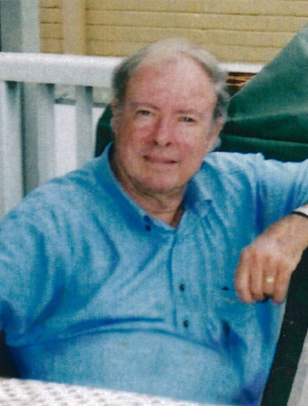
It with great regret I must advise NSWCHSSA Life Member, and former Basketball Convener and Vice-president Paul Durack passed away on Friday 30th June 2017.

Paul made outstanding contributions to school sport at all levels: the school, the zone, the region, CHS and School Sport Australia.

Paul commenced his teaching career at Bankstown Boys High School, where he was the Sports Master from 1970 until 1977. In 1977 he transferred to Cabramatta High School as the Administration Master, where he remained until his retirement in 1997.

In 1968, Paul was elected as the CHS Basketball Convener. During this time he was successful in gaining sponsorship from the Shell Oil Company for the boys, and later the girls basketball knockout competitions.

Paul was also a driving force in the establishment of the NSW versus Queensland Basketball Exchange. In his capacity as the CHS Basketball convener he initiated the transition which saw the exchange become the Australian Schools Basketball Championships. This championship continues to this day and was included in the 2008 and 2015 Pacific School Games.

Paul was a member of the CHS Blues committee from 1979 until 1997, and was a CHS Vice president from 1990 until 1997.

At the zone and region level Paul also had a distinguished career. He served as the Edmondson Zone Treasurer from 1971 until 1977, and in 1979 was elected as a Vice-president of the Metropolitan South West Region, a position he held until his retirement in 1997.

Over the years many teachers and students have benefitted from his outstanding organisational and leadership qualities.

The NSWCHSSA extends its condolences to his wife Elaine and family.

RIP Paul Durack.
