SYDNEY NORTH TRIALS INFORMATION
Please check our website and Facebook page for information relating to wet weather cancellation and postponement of trials.

Dear Parent/Carer/Guardian
Your son / daughter / ward _________________________ of _______________________ School
has been selected to attend Sydney North Trials for the selection of a Sydney North Team.

Event Details:

Sport:
Venue:
Date:
Start Time:
End Time | Students will be dismissed at completion of the trial.
Travel: | Students are to make their own way to and from the venue.
Cost:
Dash Link:

Equipment: | Students must provide their own playing equipment, lunch, snacks and water bottle.
Canteen:
Additional Information:
please include from the trial information on the website as required.
Website link:
Souvenir Apparel: | There will be no souvenir apparel sales at the event. All souvenir apparel will be purchased online via an apparel store: Information about the online store will be provided to students attending in the information and consent note. All prices include GST. Please note stock is limited and is only available until sold out. No orders will be taken. Delivery will be to your home address.  Souvenir Apparel: https://au.paladin.sport/collections/sydney-north-trials  See attached flyer.
Sydney North Convener: | Name:  School:
Zone Convener:  (If applicable, eg. most primary trials, swimming, athletics and cross country) | Name:  School:

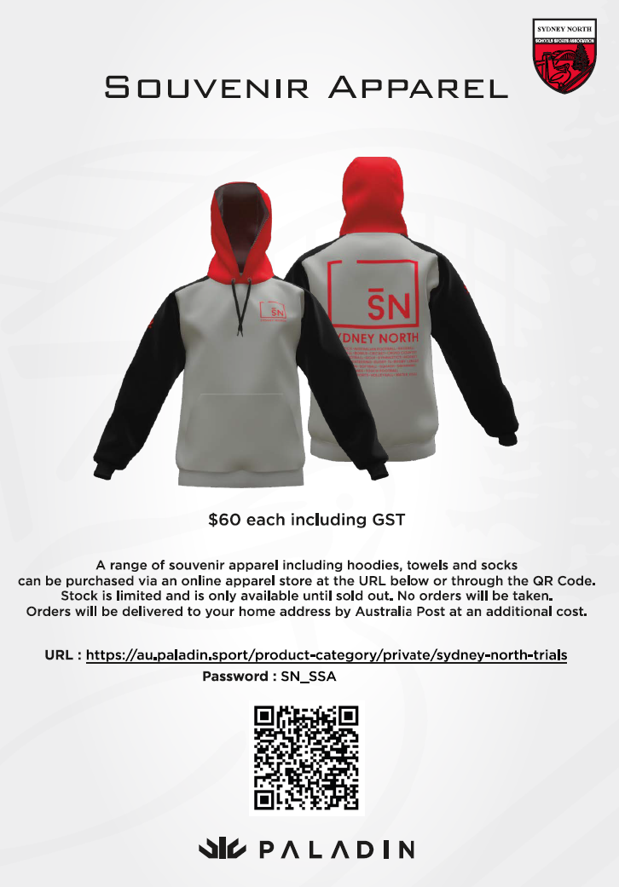

Dear Parents/Caregivers
To apply for a trial, please visit the Sydney North Trials page in Dash. Please note that in many cases particularly in primary students will attend a Sydney North Trial as part of a zone or a combined zone team. Secondary school students should discuss their nomination with the school sport coordinator prior to nominating.
Visit the link or scan the QR code in step 3 below to see which Sydney North Trials are open for applications. Parents/caregivers must apply for a trial via an online permission form through the Dash Platform to consent for a trial.
You will require the following details in order to register your child and pay the trial fee. You will be using our new system, DASH, which is a consent and registration software and allows you to provide information for your children and then safely stores this information for ease of use in the future.
Dash Online Consent form and payment if applicable must be completed prior to the trial date. https://nswschoolsportunit.dashapp.com.au/

How do I Register on Dash?
1. Register | If you have not done so previously, go to https://nswschoolsportunit.dashapp.com.au/ click “Register Now” and create your account.
2. Add your Child | If you haven’t already you need to add your children to your account. Once you log in you’ll be given this option from the dashboard. Follow the prompts and their details will be stored for use for applications.
3. Follow the link | Once you have your account set up and your child added, visit the link or scan the QR code to view Sydney North trials that are open for application: https://nswschoolsportunit.dashapp.com.au/events
4. Select Trial | Choose the trial that you wish to apply for and begin an application.
5. Registration | Complete the steps. Every application will involve a series of requirements in order to complete your application.
6. School Approval | An email will be forwarded to the school email account for school approval. All students must have school approval to attend their trial. The registrations will not be complete until it has school approval.

https://nswschoolsportunit.dashapp.com.au/events


