Where it all began!

Given the unique and diverse sporting opportunities currently available through NSW public schools, it's hard to imagine a time when there were no school sporting carnivals, no inter-school sporting competitions and limited access to playing fields and sporting facilities.

This however was the reality prior to the pioneering work begun by the founders of the public schools sports movement that commenced in 1889. This was a time of relative isolation, with, by today's standards, inefficient internal transport systems and significant distances separating towns and schools, making travel between sites difficult and uncomfortable. There was of course also no bridge connecting the southern and northern parts of Sydney across the harbour.

In 1889, The Public Schools Amateur Athletic Association (PSAAA) was formed to develop a coherent structure and systems that could provide worthwhile sporting opportunities for young people in our schools. Former President of the PSAAA Ernest Clark described the purpose of his organisation as establishing a sporting system that would ........"promote physical fitness, develop qualities of courage, determination, unselfishness, constructiveness and of teaching the values of team spirit, self-sacrifice and loyalty."

These are still some of the very qualities our schools and teachers strive to instil into their students as they reach for excellence in whatever their chosen field of endeavour.

Over many decades the PSAAA and its successors the Primary Schools Sports Association (PSSA), the Combined High Schools Sports Association (CHS) and the Girls Secondary Schools Sports Association (GSSSA) set about establishing the structures, operating principles, rules, policies and guidelines that would drive an effective competitive sports program to serve a growing number of NSW public schools and students. They soon realised change was not only inevitable but ongoing!

The advent of many comprehensive co-education secondary schools through the Wyndham revolution of the 1960's, coincided with a much clearer understanding of the ideal model for the delivery of school sport. The PSAAA was considered to have served its purpose and in 1969 it was disbanded. The girls and boys primary school sport associations soon joined forces to form the Primary Schools Sports Association, quickly followed by the GSSSA and Boys CHS amalgamating to form the Combined High Schools Sports Association. School sport would never look back.

The first official Paralympics, held in Rome in 1960 included NSW athletes Daphne Ceeney and Gary Hooper. This event significantly raised awareness of Para-Sport, highlighting the high quality of performance and the importance of competitive sport for all. Sport for athletes with disabilities began to thrive.

By now with its tiered pathway system from school to zone, to region to state and national championships, school sport was well on the move and was growing at a rapid pace. Girl’s sport was flourishing and soon extended to a much broader range of events and activities, including a growing number of non – traditional girls’ sports.

The novelty events, sack races, Maypole Dances and military style marches and drills of the past had given way to a new age of competitive sports that continued to multiply annually.
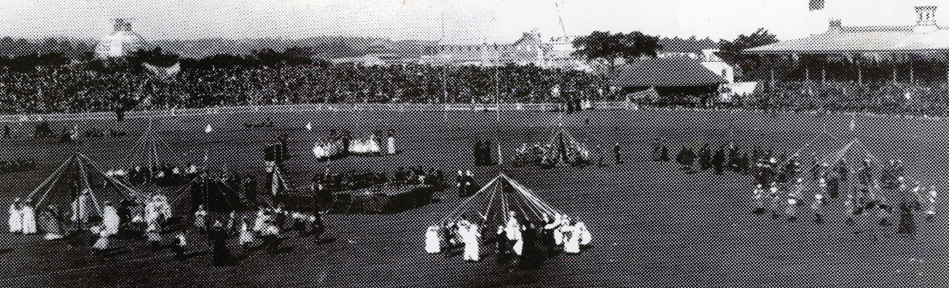

In a country where sport is so much a part of everyday life, it's no surprise that some of Australia's finest sportsmen and women developed their skills in the nursery of NSW public schools. The list of World Champions, Olympians, World record holders and Australian representatives is a long and impressive one across a wide range of sports.

Perhaps the most outstanding single athlete achievement at a competitive school sporting event was at the 1972 CHS Swimming Championships at North Sydney pool, when Graeme Windeatt from East Hills Boys High School set an Open World Record in the 800 metre freestyle. His time of 8.28.60 was accepted by FINA the International Swimming authority. This indicated not only the high quality of the participants at school sporting championships, but also was a testament to the quality of the officials and timekeepers. It's also worth noting that Shane Gould and Gail Neale, both from Turramurra High were still at school when they won Gold Medals at the1972 Munich Olympics.

For over 130 years the public school sporting bodies have administered and conducted weekly inter -school sporting competitions in all major codes for boys and girls, winter and summer. They have been the catalyst for interstate and international events and exchanges.

From Sir Donald Bradman, Betty Cuthbert, Dawn Fraser, Heather McKay, Evonne Goolagong, Bob Fulton, Reg Gasnier and Arthur Summons, the remarkable Ella family, Richie Benaud and so many others, right through to Anne Sargeant, Ian Thorpe, the Waugh brothers, Kerry Saxby, Layne Beachley, Kurt Fearnley, Debbie Watson, Tim Cahill and Steve Smith, the list of public school sport graduates goes on and on.

The real story however is so much more than a catalogue of the achievements of our greatest performers, impressive though their achievements are. The often untold story is a remarkable tale of hard work, dedication and struggle - of extraordinary and at times mundane events set against a backdrop of significant social change as the state of New South Wales developed from an infant colony to a sophisticated thriving community. In many ways the growth of competitive sport in NSW mirrors the great changes that have taken place in our society and in education during this period.

It would be difficult to cite a more outstanding achievement performed by any group of people than the legacy provided by our volunteer teachers - those men and women, who, along with local school communities, parent organisations, sporting associations and other school sport supporters have handed on, for all to share into the future. We thank them for their foresight, courage and commitment.
