 North Coast PSSA Swimming Relay Form 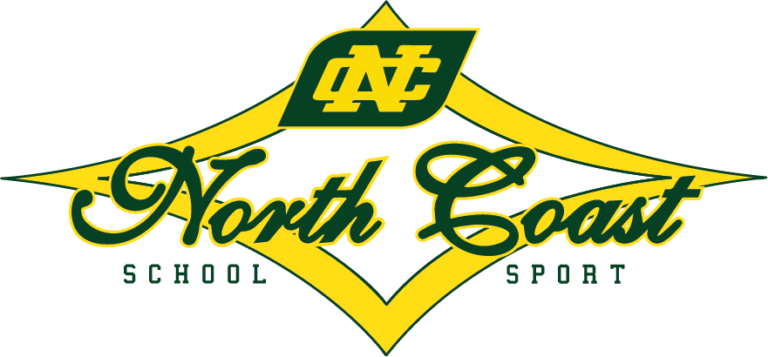
Information required | Enter your details here |  |  |  | Information required |  | Enter your details here
Please return to your Zone Secretary (found here) and North Coast School Sport Unit (nthcoastsport@det.nsw.edu.au) by Tuesday 4th March 2025.
Area | North Coast
Event | Senior / Junior
Gender | Boys / Girls
Name of School
Number | Name |  |  |  | Date of Birth
1
2
3
4
Reserve (if any)
Information required |  | Enter your details here | Information required | Enter your details here
Principal/Sports Organiser Approval |  |  | Date

NB: Students must be listed in the order they are competing, or the team may be disqualified
Information required | Enter your details here | Information required | Enter your details here
Principal/Sports Organiser Approval |  | Date

Please ensure the age of each athlete is correct

Small Schools Relay
Enrolment 26 – 54
The Peter Dobson Relay.
The rules for this event are as follows:
The Peter Dobson Relay must include students from schools with a total enrolment of more than 25 pupils but not exceeding 54 pupils. The combination of boys and girls in each team to be decided by the individual school but all children in the team must be enrolled at the same school
The classification of the enrolment will be determined by the February Staff Return.
Declaration
This is to certify that I have read the rules and indicate that our School enrolment as per the February Staff Return complies with the guidelines for this event.
Please return to your Zone Secretary (found here) and North Coast School Sport Unit (nthcoastsport@det.nsw.edu.au) by Tuesday 4th March 2025.
Name of School
Total School Enrolment (as at February staff Return)
Signed
Date
Information required | Enter your details here |  |  |  |  | Information required |  | Enter your details here
NB: Students must be listed in the order they are competing, or the team may be disqualified
Area | North Coast
Event | Senior / Junior
Gender | Boys / Girls
Name of School
Number | Name |  |  |  |  | Date of Birth
1
2
3
4
Reserve (if any)
Information required |  |  | Enter your details here | Information required | Enter your details here
Principal/Sports Organiser Approval |  |  |  | Date

Small Schools Relay
Enrolment 1 - 25
The Earl McGee Relay.
The rules for this event are as follows:
The Earl McGee Relay must include students from schools with a total enrolment not exceeding 25 pupils. The combination of boys and girls in each team to be decided by the individual school but all children in the team must be enrolled at the same school
The classification of the enrolment will be determined by the February Staff Return.
Declaration
This is to certify that I have read the rules and indicate that our School enrolment as per the February Staff Return complies with the guidelines for this event.
Please return to your Zone Secretary (found here) and North Coast School Sport Unit (nthcoastsport@det.nsw.edu.au) by Tuesday 4th March 2025.
Name of School
Total School Enrolment (as at February staff Return)
Signed
Date
Information required | Enter your details here |  |  |  |  | Information required |  | Enter your details here
NB: Students must be listed in the order they are competing, or the team may be disqualified
Area | North Coast
Event | Senior / Junior
Gender | Boys / Girls
Name of School
Number | Name |  |  |  |  | Date of Birth
1
2
3
4
Reserve (if any)
Information required |  |  | Enter your details here | Information required | Enter your details here
Principal/Sports Organiser Approval |  |  |  | Date

2025 Swimming Championships
Relay Teams
Please return to your Zone Secretary (found here) and North Coast School Sport Unit (nthcoastsport@det.nsw.edu.au) by Tuesday 4th March 2025.
Division | Sex | School
Junior | Boys
Junior | Boys
Junior | Boys
Senior | Boys
Senior | Boys
Senior | Boys
Junior | Girls
Junior | Girls
Junior | Girls
Senior | Girls
Senior | Girls
Senior | Girls
Peter Dobson | CoEd
Peter Dobson | CoEd
Peter Dobson | CoEd
Earl McGee | CoEd
Earl McGee | CoEd
Earl McGee | CoEd

