 | PSSA Awards Nomination | 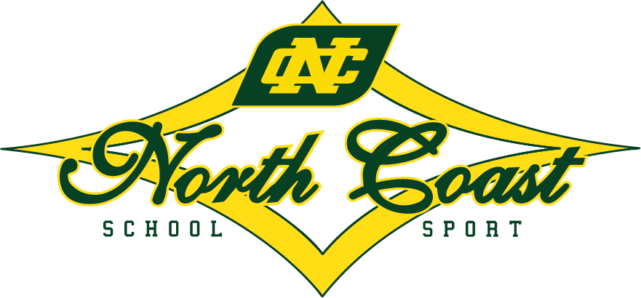

North Coast Sports Awards
Nominations are hereby invited for the North Coast PSSA Sports Awards.

Award Criteria: Sports Award
- Sporting:
Nominees must have represented New South Wales PSSA (State team or Merit team) with distinction in an individual or team sport during the current year.
- Personal Qualities:
i. The nominee must have displayed exemplary behaviour at all times.
ii. The nominee’s dress both on and off the competition arena will have been befitting a representative of the North Coast
iii. The nominee must have exhibited the highest level of sportsmanship.

Award Criteria: Achievement Award
- Sporting:
Nominees must have represented North Coast PSSA, in an individual or team sport with distinction, at NSWPSSA State Championship, 3 or more times in the current year.
- Personal Qualities:
i. The nominee must have displayed exemplary behaviour at all times.
ii. The nominee’s dress both on and off the competition arena will have been befitting a representative of the North Coast
iii. The nominee must have exhibited the highest level of sportsmanship.

Limitation

A Primary student can receive only one North Coast Sports Award per sport or only one Achievement Award. If representation takes place in subsequent years in that sport they will receive a Certificate of Recognition to be awarded at the North Coast Awards ceremony.
(This means that if a student in Year Five (5) meets the criteria for a North Coast Sports Award in a sport they will receive the award in that year. If the same student meets the award criteria again for the same sport in Year Six (6) they will receive a Certificate of Recognition.

Endorsement
The nomination must be endorsed by:
- School Sports Organiser
- School Principal
- North Coast Team Manager
Athletes with a disability who meet the specified criteria can be nominated.

Return of Nominations:

Nominations are to be returned with written citation to:

nthcoastsport@det.nsw.edu.au (preferred)

By the last day of term 3.

Thank You
NCSSA.

2025 North Coast Sports Awards Nomination Form
Nominee’s name |  |  |  | Nominee’s address
Nominee’s postcode |  |  |  | Nominee’s phone number
Nominee’s school |  |  |  | Year at school
Nominated
Sport (s)
Sport(s) and Years(s) represented North Coast:
Sport(s) and Years(s) represented NSWPSSA:
Performance details when represented NSWPSSA
(Please specify places gained, records set, team contributions, position played etc)
Other Outstanding Sporting Achievements
Personal Qualities (Please circle)
Behaviour |  | Satisfactory |  |  | Good |  | Excellent
Dress |  | Satisfactory |  |  | Good |  | Excellent
Sportsmanship |  | Satisfactory |  |  | Good |  | Excellent

Please treat this nomination as CONFIDENTIAL.
Principal’s Signature | Date | School Sport Organiser’s Signature | Date

The nomination form must be signed as indicated. The Principal’s signature indicates to the Awards Committee that this nomination is fully supported by the school.
Return - with typed citation (example attached) - to: nthcoastsport@det.nsw.edu.au
By Friday 26 September2025 (Last day of term 3)

REQUIRED CITATION EXAMPLE

Rory McLean
Cricket

Rory has excelled on the cricket field while representing his school and the North Coast for the past 2 years. This year he has gained selection in the state team and will represent NSW at the National Championships.
This year Rory captained the North Coast team to 6th place at the NSW Primary School Sports Association carnival, employing bowling and fielding strategies not often seen at Primary School level.
Rory also kept wickets for 4 full games, allowing minimal byes, taking 4 catches and effecting 4 runouts. His sharp glove work earnt him a spot on the state team.
In addition, Rory scored 166 runs at an impressive average of 55, including two half-centuries. His fluent stroke play inspired the North Coast team’s impressive batting throughout the week.
A modest sportsman, Rory’s success never gets to his head. He is a popular team member and his determination to succeed is evident in his work ethic and discipline.
Congratulations Rory on your North Coast PSSA Sports Award.

